Abstract
Numerous medications are gotten from optically dynamic mixes recognized as chiral atoms. Chiral particles include no plane of symmetry and subsist in sets of non-superimposable equal representations; enantiomers. Regularly just a solitary one of the two enantiomers is dynamic or wanted. The less wanted atom might be less viable or even have unfriendly impacts. On account of ibuprofen, a normally utilized non-steroidal calming, just a solitary one of the enantiomers, (S)- (+)- ibuprofen, is dynamic. Astereochemicalprocess used to isolate racemic mixes and segregate the enantiomers is known as chiral goals. In this examination, a racemic mixture, one contain equivalent amounts of the two enantiomers, of ibuprofen be isolated, by the arrangement of diastereomeric salts, keen on its two enantiomers. 3.1 grams of disintegrated racemic ibuprofen was responded among (S)- (- )- α-phenylethylamine to make a blend of diastereomeric salts.
In contrast to the enantiomers themselves, the diastereomeric salts contain distinctive substance and substantial properties. The diastereomeric salts of (+/ - )- Ibuprofen and (S)- (- )- α-phenylethylamine shaped have incomprehensibly excellent dissolvability. One of the diastereomeric salts, the ideal (S)- (+)- ibuprofen, isn't dissolvable in watery arrangement and hastens out. Utilizing a plan of recrystallization and fluid taking out, and resulting in turning to vanish of the dried natural sheets; the two enantiomers of ibuprofen be isolated and recouped. The enantiomers were recognized and tried for virtue by dissolving point investigation [(S)- (+)- Ibuprofen; test: 50-53°C; writing: 40-53°C], and polarimetry values [[(S)- (+)- Ibuprofen; Specific turn, test: +52°, writing: +59°]. The optical virtue of the (+)- ibuprofen was about 88.14%. These outcomes propose a second and productive technique for the partition and disengagement of the ideal ibuprofen enantiomeric structure.

By and massive Reaction: Resolution of Racemic Ibuprofen
(+/ - ) Racemic Ibuprofen (S)- (- )- α-phenylethylamine Diasteromeric Salts: (Both IBU enantiomers). Racemic ibuprofen is a mixture containing equal amounts of R (-)- ibuprofen and S (+)- ibuprofen.
Reactions of racemic mixtures with enantiomerically pure chiral reagents gives diastereomers.
Resolution is the process whereby racemic ibuprofen and a single enantiomer of α-phenethylamine are reacted together to form 2 different diastereomeric salts. Resolution is used as it is the most effective method and yields pure compounds, also it is used in large scale productions. This is when compared with asymmetric synthesis. resolution in a chemical process separating temporary the two enantiomer into diastereomers. This means that ravemic mixtures to be separated is reacted with single enantiomer of the second chiral compound. For diastereomers have different physical properties, they are used to achieve resolution of racemic.
Introduction
In the pharmaceutical industry, numerous drugs are prepared of chiral molecules. lots of of these molecules include non-superimposable mirror images known as enantiomers. Enantiomers contain alike physical and chemical properties but tend to react in a different way with further chiral compounds []. The biological effects of enantiomers can be vastly different []. In the past, drugs were often sold commercially as racemic mixtures. Due to the costs of processing and access to necessary supplies, it was not always economical to resolve drug molecules to enantiomerically-pure compounds. However, advancement within chemistry comprise made the processing of optically pure substances more reasonable, and the production of solidarity-enantiomer drugs is flattering more ordinary ^{[ii]}. In some cases the results of racemic drug mixtures are only lessened effectiveness or potency; where one of the enantiomers is either less effective or inert compared to the other active enantiomer. Such is the case for ibuprofen, where the (R)-(-)-ibuprofen is inactive, but not harmful, and can be converted to the more desirable (S)-(+)-ibuprofen enantiomer [].
However, in some drugs, one of the enantiomers may have adverse or even harmful effects. A good example is the case of the drug Albuterol, used to treat asthma, where the once thought inactive enantiomer had been found to intensify the disease []. Furthermore, the optically pure form of the desired enantiomer has also been found to be many times more effective and longer lasting in the body. Initially, the resolution of the enantiomers of Albuterol used liquid column chromatography; a less efficient and more expensive method of separating a racemate. But, advancements in resolution technology have allowed methods like the isolation of diastereomeric salts and strong-acid treatment of many compounds to separate enantiomers. And, in the case of drugs like ibuprofen and Albuterol, this method provides a less expensive resolution procedure resulting in higher enantiomeric purity.
Results and discussion
Isolation of Ibuprofen
After the recrystallization process that is carried out aimed at improving purity, then followed by acidification process, the amount of ibuprofen that is recovered were as shown. The weight of the round beaker = 57.433g. The weight of the beaker with the content = 66.25g. And therefore, the weight of ibuprofen = 8.817g. Melting point is measured at 75.9C. The figure showed below shows (S) -(+) - ibuprofen

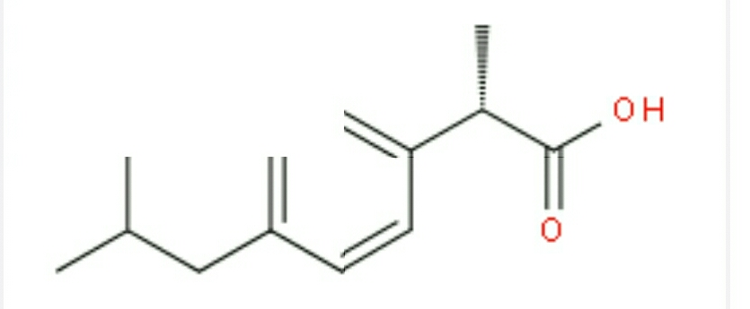

(S) -(+) - ibuprofen
The percentage of the ibuprofen that is recovered from the process can be calculated by computing the amount of pure ibuprofen recovered over the total amount of racemic mixtures times 100%
= 8.817g/66..25g * 100
= 13.30 mmol, C %
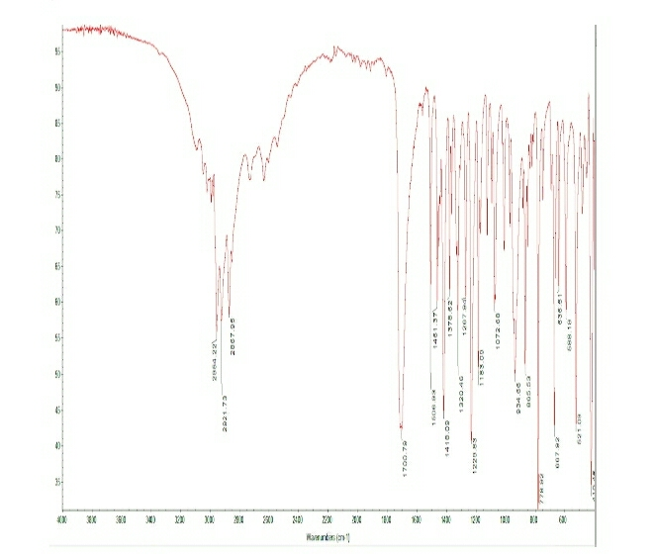
In the formation of Diastereomeric Salts, melting points reached is 168.9°C. And that of enantiomerically Pure Ibuprofen Recovery at melting point = 63.8°C

IR spectrum of ibuprofen that has been recovered.
In isolation of Ibuprofen from the mixtures, two processes are carried out, recrystallization and acidification. Resulting (S)-(+)-Ibuprofen has better analgesic effects than racemic mixtures made from ibuprofen enantiomers. The weight of ibuprofen that was formed was 8.817g. During the formation of diastereomeric salts, their different solubility property they have been used and one enantiomer is made.
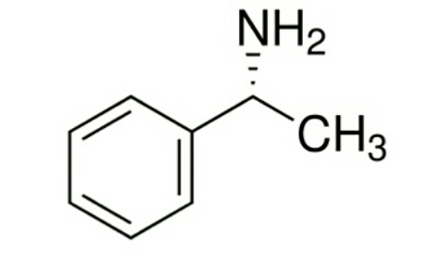

The recovery is undertaken of s-(+)-Ibuprofen from the salt of diastereomeric takes place. To indicate how these entire processes happen, diagrams representation is used. To show how bond(s) from diastereomeric salts, lines are used as shown
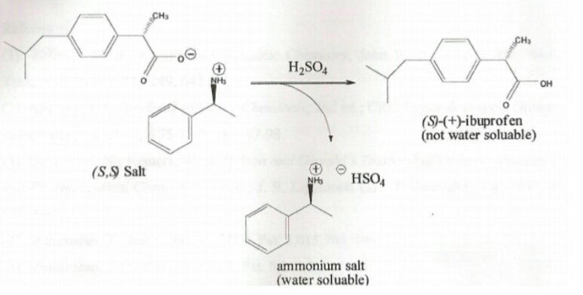

(S, S) Salt undergoes dissociations and double bonds and broken forming new bonds of (S)+- ibuprofen.68.3°C is the melting point where enantiomerically pure ibuprofen is recovered. The temperatures reached are close to the range of 75°C - 85°C. While forming diastereomeric salts, high melting points of 168.5°C are reached. Meaning that bonding was stronger and required high melting points temperatures.
Conclusion
This test demonstrates the fruitful goals of the ibuprofen enantiomers. The % recuperation of every one of the enantiomers was lower than it could be, yet this could be refined. All the more imperatively, the virtue of the enantiomers was modest to high. The visual immaculateness of the ideal, dynamic (S) - (+) - ibuprofen, enantiomer was upper. These backings this strategy for goals as proficient; being that the dissolvability properties of the related diastereomeric salt when responded with (S) - (-) - α-phenylethylamine encourage this procedure and consider simple recuperation and recrystallization of the ideal item.

Experimental
The methodology in this test utilizes the separation of diastereomeric salts in addition to solid corrosive management to determine the enantiomers of ibuprofen. This system uses the contrasts among enantiomers and diastereomers concerning physical and concoction properties. The two enantiomers of ibuprofen will respond with an amine base similarly. By utilizing a lone type of a chiral amine base and returning it among a racemate carboxylic corrosive like ibuprofen, the outcome is a blend of diastereomeric salts; comparable, yet fundamentally unique and having distinctive substantial properties. In this system, the distinction in dissolvability is utilized to isolate the salts, and after that consequent solid corrosive fermentation permits the segregation and recuperation of the unadulterated enantiomers
First, in this test; racemic ibuprofen was broken up and warmed in 0.24M KOH. The electrons from the oxygen assault the hydrogen on the carboxylic acid and deprotonate the (+/ -) - ibuprofen. Potassium is a decent leaving gathering and isolates from the hydroxide particle, that will shape H2O. The deprotonated (+/ -) - ibuprofen will ionically draw in the free K+ particles. The expansion of the (S)- (- )- α-phenylethylamine, having an amine bunch with a solitary pair of electrons, will assault protons in the arrangement (gave from the water and H3O+), the emphatically charged (S)- (- )- α-phenylethylamine, having picked up a proton, will ionically respond with the deprotonated ibuprofen enantiomers, supplanting the K+ and making the diastereomeric salts . The (S, S) salt is insoluble in watery arrangement and hastens out, while the (R, S) salt is dissolvable and stays in arrangement [vii]. The accelerate is vacuum sifted, and the salts are viably isolated.

The strong from the initial step is recrystallized in 2-propanol Recrystallization is utilized to build the visual immaculateness of the strong.

The precious stones are then disintegrated in 2M H2SO4, a solid corrosive, for five minutes. This is done to re-protonate the ibuprofen. This isolates the ibuprofen from the (S)- (- )- α-phenylethylamine. The (S)- (+)- ibuprofen enantiomer isn't dissolvable in watery arrangement and is separated with t-butyl ether (Figure The natural layer is washed with H2O and NaCl, to expel polluting influences from the natural layer. The layers are isolated, detaching the (S)- (+)- ibuprofen.

The filtrate from the earliest starting point of the test is blended with H2SO4 to re-protonate the (R) - (-) - enantiomer of ibuprofen, isolating it from the phenylethylamine. When isolated the (R) - (-) - enantiomer of ibuprofen isn't solvent in fluid arrangement (like the (+)- enantiomer). The substance is removed and washed as expressed above (Figure 2, Part D). The removed items were gathered gauged and dried and tried for immaculateness.

The prompt precipitation after including the (S)- (- )- α-phenylethylamine bolsters the development of a diastereomeric salt. The (S, S)- diastereomer of the salt isn't dissolvable in fluid arrangement [iii]. Before recrystallization the dissolving purpose of the framed strong was taken (135-145°C), after recrystallization, the liquefying point was taken once more (167-170°C); showing an expansion in immaculateness.

After fermentation of every one of the salts, the accompanying dissolving point investigations and polarimetry tests upheld the recuperation and confinement of every one of the ibuprofen enantiomers. The polarimetry tests for explicit revolution demonstrated that the strong from part C was the (+)- enantiomer, and the strong from part D was the (- )- enantiomer. The determined explicit turn of the (+) - enantiomer (+52°) was nearer to the writing esteem (+/ - 59°), than the (- )- enantiomer (- 38°). The optical immaculateness of the (S) - (+)- enantiomer was 88.14%, while that of the (R)- (- )- enantiomer was just 64.41%. This distinction can be effectively clarified by means of the procedure of recrystallization. The recrystallization of the (S, S)- salt expanded the immaculateness of the recuperated item, and in this way the optical virtue. This demonstrates this is a viable procedure for the recuperation of the ideal, dynamic, enantiomer of ibuprofen.

Endnotes
Sigma-Adrich, Ibuprofen, 4883, Material Safety Data Sheet, Version 4.1, Revision Date 10/22/2010
Sigma-Aldrich. (2011). (s)-( )-ibuprofen . Retrieved from http://www.sigmaaldrich.com/catalog/ProductDetail.do?lang=en&N4=375160|ALDRICH&N5=SEARCH_CONCAT_PNO|BRAND_KEY&F=SPEC
Organic Chemistry 8th Ed, John McMurry, Brooks/Cole, 2012, p150-154
Enantiopure drug. (2011, August 2). In Wikipedia, The Free Encyclopedia. Retrieved 05:34, November 25, 2011, from http://en.wikipedia.org/w/index.php?title=Enantiopure_drug&oldid=442729239
McCullagh, J.V. J. Chem Ed. 2008, 85, 941-943
Bill T. Ameredes, Ph.D. and William J. Calhoun, M.D. American Journal of Respiratory and Critical Care MedicineVol 174. pp. 965-969
Organic Chemistry 8th Ed, John McMurry, Brooks/Cole, 2012, p147-153
Organic Chemistry 8th Ed, John McMurry, Brooks/Cole, 2012, p156-160
McCullagh, J.V. J. Chem Ed. 2008, 85, 941-943
Organic Chemistry 8th Ed, John McMurry, Brooks/Cole, 2012, p161-163

